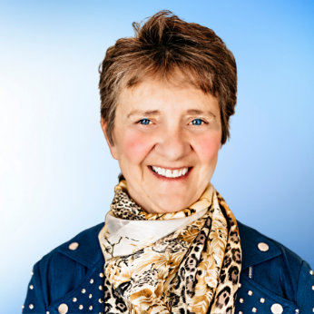
BETTY-ANNE HOWARD
For over 25 years, Betty-Anne has been guiding individuals, couples, and families to realize their financial dreams. Prior to that time, she worked as a social worker and taught at Queen’s University and St. Lawrence College in Kingston. She currently specializes in strategic philanthropic planning and has redirected millions of dollars to the charitable sector while dramatically reducing taxes for those clients she has assisted.
Betty-Anne is an accomplished author and speaker. She has been interviewed by many different publications including The Globe and Mail, Carleton University’s publication, Philanthropy in Action and featured in other charity newsletters. She is a member of the Canadian Association of Gift Planners having also been their Ottawa Education Chair and is now Chair of the Ottawa Chapter. For two years she served as a Trustee at the Institute for Advanced Financial Education and was actively involved on the Executive Committee with the Kingston Chapter of Advocis.
She’s been honoured with numerous awards for her public speaking and has facilitated a variety of inspirational talks to organizations such as the Ottawa Estate Planning Council, Friends of the Earth Canada, Action Canada and the Canadian Association of Gift Planners.
Betty-Anne has been an active Board and Committee member for such organizations as Queen’s University Ban Righ Foundation, the Kingston Unitarian Fellowship, the Sexual Assault Crisis Centre and the Kingston Arts Council. She has been on the Board of the Kingston District Health Council where her involvement was instrumental in obtaining Ministry of Health Funding for the first Sexual Assault Crisis Centre in Canada.
Betty-Anne lives with her spouse and adopted golden doodle, Phoenix, on beautiful Bass Lake between Kingston and Ottawa. They love spending time with their two horses, Thor and Copper

